Terms of Reference
Digitalization of the Media Register of the Serbian Business Registers Agency (SBRA)
Donor Trust Fund – Serbia Digitalization for Business Environment
(P174555)

Background
International Bank for Reconstruction and Development (hereinafter: the World Bank), acting as administrator of the European Commission, on behalf of the European Union for the EC – World Bank Partnership Programme Part III for Europe and Central Asia Programmatic Single-Donor Trust Fund – Serbia Digitalization for Business Environment, extended a grant (hereinafter: Grant) to the Republic of Serbia to assist in the financing of the project “Serbia Digitalization for Business Environment” (hereinafter: Project).

Implemented within the framework of the Action Programme for the Republic of Serbia, adopted by the European Commission on November 28, 2019 and confirmed by the Financial Agreement with the European Commission, which was signed by the Republic of Serbia on February 6, 2020, the Project refers to the Result 1 of the said Action Programme: Improvement of the coordination of reforms in the field of business environment and optimization of the regulatory environment for economic entities. It enables digitization of 20 business episodes and accompanying registers and records, which will in turn create conditions for the Public Policy Secretariat (PPS) of the Government of the Republic of Serbia to further support improvements of the business environment.

The Project also entails management and improving the unified Registry of Administrative Procedures (hereinafter: RAP) and its publicly accessible portal. Digitization of administrative procedures would directly contribute to the reduction of the administrative burden to businesses, through savings resources, increased transparency, predictability and stability of business environment.

The objective of the Project is to improve aspects of the business environment through the digitalization of selected government-to-business services in the prioritized sectors. The Project consists of the following parts:

Part 1. Upgrading the Registry of Administrative Procedures: Support the upgrading of RAP to enhance its functionality and usability.
Part 2. Identifying potential Business Episodes: Identify at least 20 government-to-business services that have potential to be simplified and digitized under a Business Episode format.
Part 3. Digitization and piloting of Business Episodes: Digitization and piloting of at least 20 government-to-business administrative services, (a) selected by Public Policy Secretariat, in consultation with the Ministry of Economy of the Member Country, (b) in highly relevant sectors, (c) under the Business Episodes format, and (d) through a Member Country government portal (whether RAP or other portals operated by a Member Country government agency).
Part 4. Enhance Data Registries: Support the upgrading of Data Registries, primarily those required for the digitalization of the 20 Business Episodes, including by (a) considering the most recent business regulations and any relevant reforms, and (b) designing a business-friendly online interface that allows for easy navigation and offers an integrated online feedback mechanism for businesses.
Part 5. Implementation Support: Strengthen the Recipient staff’, and other government officials’, capacity through the organization of workshops and training on Business Episodes, and the provision of Operating Costs.

Objectives of the assignment
The primary objective of this project is to engage consulting services to replace the existing Media Register information system operated by the Serbian Business Registers Agency (SBRA) with a new, technologically and functionally enhanced solution. This system will enhance and streamline specific business episodes throughout the life cycle of media entities, including their establishment, daily operations, expansion, and cessation.
By focusing on these key phases, the consulting services will facilitate the development of a system that fully supports the smooth execution of business processes and data registration by internal users, enhancing the services provided to the agency's customers. The new system will significantly reduce manual, paper-based procedures, enable seamless electronic submission and processing of requests, and ensure compliance with the latest legal requirements, ultimately improving operational efficiency and customer satisfaction.
This upgrade is necessitated by the new Law on Public Information and Media (2023) and the Strategy for Public Information System Development (2020-2025 which outline the need for full digitalization of the Media Register's operations. The updated system should significantly reduce manual, paper-based procedures and enable seamless electronic submission and processing of requests. The focus will be on streamlining administrative processes and improving service delivery for external users, including media companies and regulatory bodies.
In addition to improving the operational efficiency of the Media Register, the new system must ensure full compliance with the latest legal requirements and support future scalability to accommodate new functionalities or regulatory changes. Integration with existing internal SBRA systems and external government systems is essential to ensure consistency and interoperability with broader e-Government platforms.
The assignment also aims to ensure that the new system is user-friendly, supporting users with basic computer skills, and includes provisions for comprehensive training materials and user manuals. The system should be flexible enough to accommodate future updates as legal frameworks evolve.

Description of the Current System
The existing information system of the Serbian Business Registers Agency (SBRA) consists of multiple application and technical components that enable the processing of data and submissions across various registers. These systems are domain-specific but also utilize shared technical components to ensure consistency and efficiency in all SBRA business processes.

Description of the Current SBRA Infrastructure
The existing information system of the Serbian Business Registers Agency (SBRA) comprises multiple application systems and components. Some are domain-specific, others perform common functions, and some are specialized technical components utilized across all domains.

Main Elements of the SBRA Infrastructure:
- Registry Components: These handle the specific needs of various registers within the agency.
- Common Internal Systems of the Agency: Shared systems that provide internal support across different functions.
- Common Technical Components: Technical tools and services used by all registry modules.
- Unified Reception and Document Orchestration ("ABC" Registry Office): Manages the intake and distribution of documents within SBRA's business functions.
- Electronic Operations Components: Systems that facilitate e-registration and public searches.
- Integration Management Component: Ensures interoperability and data exchange between different systems and external platforms.
High Level Architecture Diagram of a typical digitilized Register is given below:
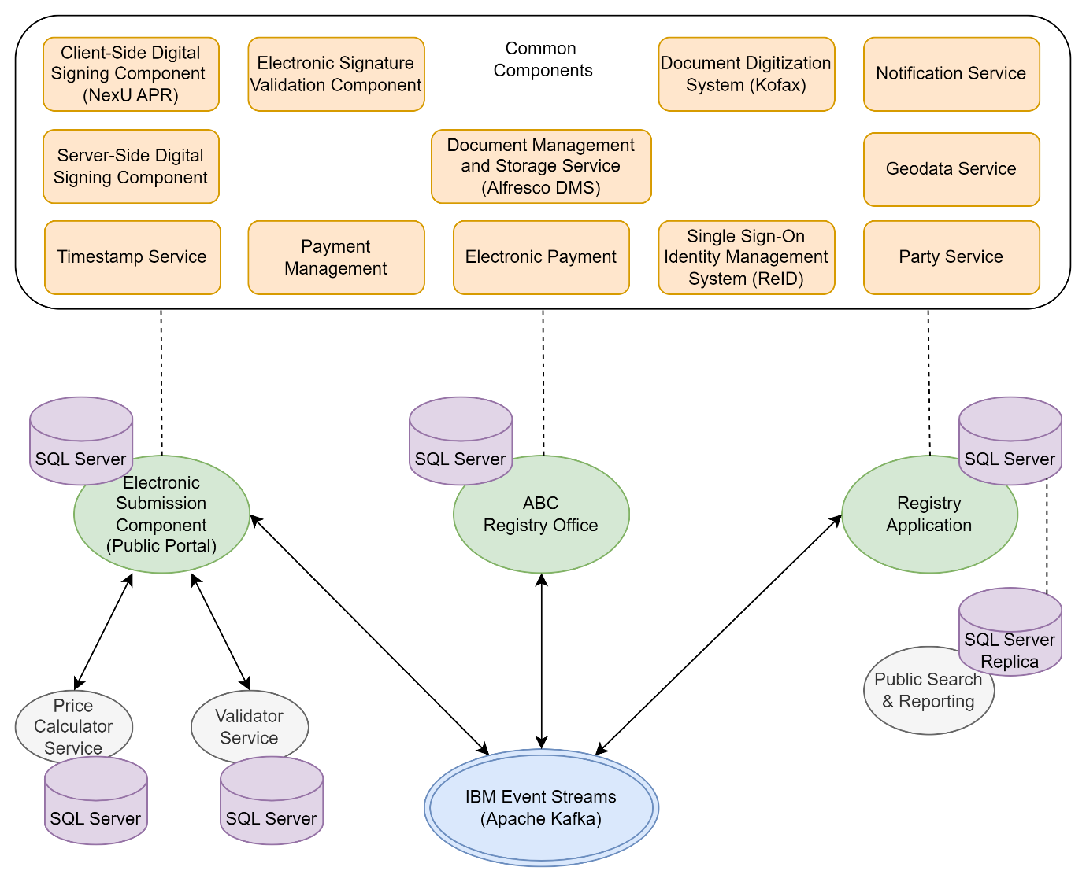
Figure 1 High-level architecture diagram of typical SBRA register

Unified Reception - "ABC" Registry Office
The "ABC" unified reception system enables the intake of both paper-based and electronic submissions. It integrates with the central electronic registry office at the national level and facilitates data exchange with other registers within the SBRA information system.
The "ABC" electronic registry office manages all incoming documents, including requests, letters, applications, and other submissions. It is connected to all domain-specific applications responsible for registration processes within the agency.

Document Digitization System ("Kofax")
Upon receipt, paper documents are logged into the electronic registry office, with each document assigned a unique barcode. All registered documents are scanned using the Kofax system and stored in appropriate repositories. The unique barcode allows these documents to be accessed across all domain-specific application systems.

Payment Management and Financial Control System
This system records all services for which the agency charges fees to users, such as registration procedures and the sale of data and reports. It links the services provided with the corresponding entries in the agency's payment account statements.

Single Sign-On Identity Management System
A common application system responsible for managing user identities and controlling access. It includes modules for access control to web applications for both external and internal users.

Document Management and Storage Service (Alfresco DMS)
The Alfresco Document Management System is responsible for storing electronic documents and managing document workflows.
- REST Services: Alfresco provides multiple REST services for data exchange with other system components, including adding new documents and retrieving existing ones.
- Document Identification: Documents in the Alfresco repository are uniquely identified using a barcode system compliant with the EAN13 standard. Each document added receives a unique barcode, which is used for document retrieval.
- Document Conversion Service: An auxiliary service converts Microsoft Word documents into PDF format, leveraging Alfresco's robust document conversion capabilities. Service parameters are specified within the service call address (URL Query String format).

Other Key Components
Important horizontal technical components used across the agency's information system include:
- Client-Side Digital Signing Component: Allows users to digitally sign documents using a digital certificate from a card or, in the future, remotely via cloud services.
- Server-Side Digital Signing Component and Future e-Seal: Enables server-side digital signing, with plans to implement an electronic seal.
- Timestamping Component: Provides trusted timestamps for electronic documents.
- Electronic Signature Validation Component: Validates digital signatures on electronic documents.
- Electronic Payment Component: Facilitates online payment processing.
- Notification Sending Component: Manages the distribution of notifications to users.

Typical SBRA technology stack
A typical SBRA portal for external users is developed using the Angular web application framework on the client side. The technology stack on the server side consists of the ASP.NET Core framework, Entity Framework Core, and SQL Server database.
Similar SBRA registries have been implemented using the .NET framework, Entity Framework as Object-Relational Mapping.(ORM) tool, and SQL Server database.
IBM Event Streams is used for asynchronous messaging between the Portal, Registry application, and the „ABC“ Registry Office.
The Media Register should be developed using the same technology stack.

Description of the Current Media Register
The Serbian Business Registers Agency (SBRA) currently uses an internally developed IT solution to support the establishment of the Media Register, in accordance with Article 141 of the Law on Public Information and Media ("Official Gazette of the Republic of Serbia", No. 83/2014, 58/2015, and 12/2016). The Media Register has been operational since February 13, 2015, and serves as a unique, centralized, electronic database of media outlets.
Following the adoption of the new Law on Public Information and Media ("Official Gazette of the Republic of Serbia", No. 92/2023), which came into effect on November 4, 2023, the Media Register continues to operate in compliance with the updated legal provisions.
The current database used in this solution is MongoDB.
To gain insight into the existing processes performed in the Media Register, the key types of applications/submissions that are currently submitted in paper form can be listed as follows:
- Registration Applications:
  - Media registration in the Register
  - Changes to registered data
  - Deletion of media from the Register
- Other Forms:
  - Request for correction of errors
  - Request for a refund of wrongly paid fees
  - Request for issuance of a copy of a decision
  - Request for issuance of an extract
  - Request for issuance of a certificate

Basic information about the Media Register can be found on the SBRA website, section: Registers -> Media -> About Register.

Scope of Work
The scope of the project includes the replacement of the existing Media Register information system with a new, enhanced system from both a technological and functional perspective. The project will be implemented in the following key phases:

Inception report
- Functional Requirements Definition: The Consultant will provide a ToBe vision of the new system (including internal processes and external services) and confirm a comprehensive understanding of all functionalities required for the new system, including internal processes and external services. They will detail it where necessary in cooperation with the Client—SBRA.
- Transitional Requirements Definition: Propose a pertinent approach for transitioning from the existing system to the new solution without disrupting ongoing operations.
- Non-Functional Requirements Definition: The Inception Report will outline architectural, performance, security, scalability, flexibility and usability requirements.
- Integration Requirements Definition: Specifying integration needs with existing internal SBRA systems and external government platforms, including necessary customizations to ensure seamless operation.
- Validation with the Client: The Inception Report will ensure all technical requirements are understood and validated by the client before proceeding to the next phase.

Business Analysis and Documentation Development
- Technical Specification drafting: The Consultant will work with SBRA to draft the Technical Specification of the new software (based on the ToBe approved vision, developed during the previous phase).
- User Stories: Consultant will detail user stories that describe scenarios for use case implementation, providing narratives of how users will interact with the system in various situations.
- Software Design Document (SDD): Drafting of the Software Design Document (SDD) to outline the technical design and architecture of the system, ensuring it meets all specified requirements.
- SDD Verification: Verifying the functional and technical specifications to ensure alignment with the identified requirements and business needs.

System Implementation
- Development the Application for Internal SBRA Users: Building a registry management system tailored for internal SBRA users to manage media registration processes. All applications must be received through this new solution, centralizing the intake process.
- Development and Implementation of the Electronic Submission Component (Portal) for External Users: Creating a user-friendly portal for external users to submit electronic requests, with features for validation and payment processing.
- Database Definition: Defining the new database structure, ensuring it supports future scalability and legal compliance.
- Integration Setup: Establishing integrations with internal and external systems, including the unified reception system ("ABC") for document submission and management.
- Deployment of Required Components: Implementing an automatic deployment procedure to set up all necessary system components. Setting up all necessary system components on the appropriate environments for testing and production.

System Testing
- Preparation of Documentation for User Acceptance Testing (UAT): Creating the necessary documentation for user testing, ensuring clear instructions and testing scenarios.
- Unit Testing: Conducting tests on individual software components to verify their functionality.
- Integration Testing: Testing the interaction between different software components to ensure they work together as expected.
- Usability Testing: Evaluating the system's user interface and user experience to ensure it is intuitive, user-friendly, and meets the needs of end-users.
- User Testing: Allowing internal and external users to test the system under real-world conditions to ensure it meets their needs.

Development of Technical and User Documentation
- Preparing comprehensive documentation for both technical teams and end users, including system operation guides, troubleshooting instructions, and user manuals.

Training
- Training of internal SBRA Users: Providing training sessions for internal SBRA users, covering detailed functionality and system administration.
- Administrator Training: Offering specific training for system administrators to manage and maintain the system post-deployment.

System Go-Live
- Installation in the Production Environment: Deploying the system in the live environment, ensuring all components are functioning correctly.
- System Launch: Officially launching the system for public and internal use.
- System Stabilization: Monitoring the system post-launch to address any initial issues and ensure smooth operation.

Decomposition of Functionalities
The new Media Register system must fully support all registration procedures related to the Media Register, as mandated by the Law on Public Information and Media. The system is expected to integrate seamlessly with SBRA's internal processes and external systems to ensure efficient and compliant operations. Below is a breakdown of the key functionalities of the system:
- Registry Management Component – Internal Users (Registry Application)
The registry management application will be designed for internal SBRA users, providing them with a comprehensive interface to manage the Media Register efficiently. The application must support the following functionalities:
- Submission Handling: The application should allow users to receive and process registration applications and other requests submitted in both paper form (via "ABC" reception) and electronically (via the portal). This includes:
  - New media registration applications
  - Requests for changes to registered media data and documents
  - Requests for deletion of media from the Register
- Task Assignment and Processing: The system should enable the assignment of submitted requests to relevant SBRA employees for processing.
- Data Entry: For paper submissions, users will be able to manually input data into the system. For electronic submissions, the data will be automatically populated.
- Request Processing: The system must support the processing of both paper and electronic submissions, including document validation and application review.
- Decision Making: The system will allow internal users to issue decisions on registration applications. This includes generating final decisions and the option to cancel improperly registered cases.
- Document Generation: The application should generate registration decisions based on selected options and publish them on SBRA’s website. This includes:
  - Decisions provided directly to applicants
  - Decisions published on SBRA’s public website
- Expedition of Documents: The system should prepare outgoing documents based on how the applicant submitted their application:
  - For paper submissions, documents will be sent as per the applicant's preferences.
  - For electronic submissions, the Registrar’s decision will be delivered as a digitally signed electronic document to the applicant’s email, using the notification service.
- System Administration Access: Authorized internal users must be able to manage system settings and user permissions within the registry application.

Use Case Diagram of key processes in Registry application is given below:
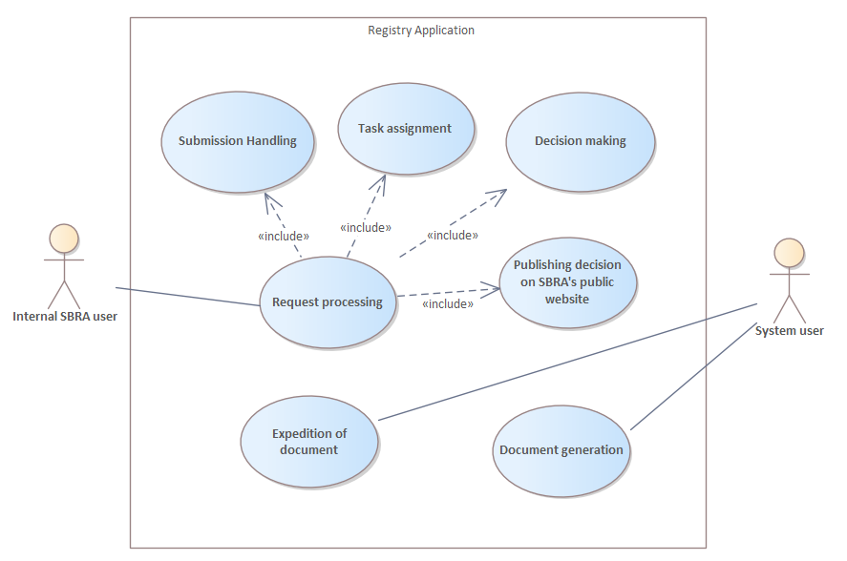
Pocture 1. Use Case diagram of key processes in Registry application
- Electronic Submission Component – External Users (Public Portal)
The system must allow external users to submit applications electronically through a dedicated portal. This component must include the following functionalities:
- Electronic Submission: External users must be able to submit various types of registration applications and requests in line with legal regulations. The submission process will include:
  - Selection of the appropriate registration application/request
  - Input of relevant data, with validation rules applied during form completion
- Document Attachment: Based on the type of application, users will be required to attach necessary documentation. The system will display only the allowed types of documents for each specific application.
- Fee Calculation: The system will inform the applicant about the applicable fee based on the type of request submitted.
- Electronic Payments: The portal must allow users to make payments for submitted applications electronically.
- Digital Signature: Users must be able to digitally sign their application using a qualified electronic signature. The system will validate the signature using SBRA's existing signature validation component.
- Notifications and Document Delivery: Upon successful submission, the system will deliver decisions to the applicant via email and e-Sandbox (eSanduče) as digitally signed electronic documents. The system should integrate with SBRA notification service for this purpose.
- Enhanced Services for Successful Submission: The SBRA’s existing services for payment calculation and request validation may be extended to support the specific requirements of the Media Register.

Global Use Case diagram for Electronic submission of application is given below:
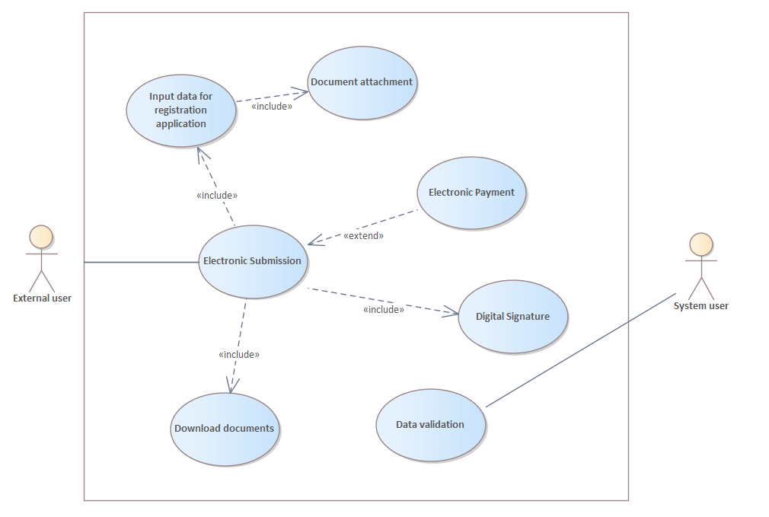
Figure 2 Use Case Diagram for electronic submission
The BPMN diagram for the submission of the electronic application and processing in the registration application is provided under Annex 1: BPMN diagram of the registration process

Integrations
The existing information system of the SBRA consists of various application systems and components. Some of these components are domain-specific, others serve common functions, and some are specialized technical components used across all domains. It is essential to ensure that the future Media Register system integrates smoothly with these existing systems.
The introduction of additional integrations must not disrupt the current processes for handling requests in the registry application or the Public Portal. The chosen vendor will receive the source code and documentation for the existing registers to make any necessary changes, ensuring that the registry continues to operate effectively with the newly implemented components.
The following table outlines the key integrations required for the future Media Register information system, detailing the existing components of the system and the corresponding components of the new system that need to be integrated:
Integration of the Future Media Register Information System with Existing Components | Component of the Future Information System to be Integrated
Unified Electronic Reception - Registry Office "ABC" | Registry Application and Public Portal
Document Digitization System ("Kofax") | Registry Application
Payment and Financial Control System | Registry Application and Public Portal
Single Sign-On Identity Management System – system for unified login, user identity management, and access control | Registry Application and Public Portal
Electronic Payment Component | Public Portal
Client-Side Digital Signing Component (using digital certificate from a card or remotely (cloud)) | Public Portal
Server-Side Digital Signing Component | Registry Application
Electronic Signature Validation Component | Public Portal
Timestamping Component | Public Portal
Document Management and Storage System (Alfresco DMS) | Registry Application and Public Portal
Address Register managed by the Republic Geodetic Authority – GEODATA | Registry Application and Public Portal
Notification Sending Component | Registry Application and Public Portal

Improvements for Legal Compliance
As outlined in the Strategy for the Development of the Public Information System of the Republic of Serbia for the period 2020–2025, and based on the new Law on Public Information and Media ("Official Gazette of the Republic of Serbia", No. 92/2023), which came into force on November 4, 2023, several new systems and integrations will need to be established. These legal provisions also impact the Media Register, which falls under the jurisdiction of the Serbian Business Registers Agency (SBRA). The future system must comply with these regulations and be integrated with both existing and new systems.

Integration with SBRA Status Registers
The law specifies that a media publisher can be an entrepreneur or a legal entity that must be registered with the authority responsible for business registers (SBRA). Therefore, the future Media Register system must integrate with SBRA’s status registers to facilitate the selection of publishers based on the entry of certain identification data (e.g., registration number or tax number).
Additionally, Article 49, Paragraph 2, Item 2 of the Law mandates that a media entity must be deleted ex officio if its publisher is removed from the register in which it was registered.
To ensure proper integration with SBRA’s status registers, relevant documentation concerning the current integrations of other systems with the status registers will be made available to the selected contractor. This documentation will serve as the basis for defining which status registers to integrate with, the method of integration, and the steps within the process where integration is required.

Integration with the Unified Information System (UIS) Managed by the Ministry Responsible for Public Information
The Law also mandates the establishment of a Unified Information System (UIS), which will be operational from January 1, 2025. The Ministry responsible for public information will manage the UIS to support and monitor the co-financing of public information projects. All project co-financing procedures will be conducted exclusively through UIS.
The Ministry will develop and maintain UIS with the technical support of the state administration body responsible for designing, building, linking, developing, and maintaining information and communication technology resources and infrastructure necessary for providing e-Government services, as well as supporting the application of these technologies.
UIS will include data on media, publishers, and media content producers, which are subject to registration or record-keeping as prescribed by the Law. This includes the following details:
- Media registration number
- Publisher registration number
- Tax number
- Business name and headquarters of the publisher
- License number for providing media services issued by the Regulatory Body for Electronic Media
These data will be obtained directly from the Media Register or the Media Content Producers Registry, meaning there will be a direct connection between the Media Register, the Media Content Producers Registry, and UIS.
The system will need to establish a two-way integration with UIS to enable the exchange of data and documents related to:
- Decision on the allocation of funds
- Basis for fund allocation (e.g., regulation or de minimis rule)
- Publisher’s registration number
- Amount of allocated funds
- Media registration number
The details of this integration will be defined during the analysis phase, which will be conducted with the selected contractor. SBRA will provide the necessary documentation related to the existing UIS during and after its establishment and implementation.

Other Integrations
Any other integrations not explicitly described in this document, whether with internal or external systems, may be requested by the Client (SBRA) as needed. The specifics and status of these requests will be evaluated on a case-by-case basis.

System Architecture
The new components, upgrades, and adjustments implemented as part of this project must adhere to and support the following architectural principles:
Architectural Principle | Description
Independence and Autonomy of Software Components | Each component should operate independently to allow for technological heterogeneity across the system.
Flexibility | The system must be adaptable to frequent legal and business changes.
Ease of Introducing New Services | The architecture must allow for the seamless introduction of new electronic services.
Scalability | The system must support future growth, including the addition of new processes, services, increased data volumes, and user numbers.
Isolation of Core Registry Functionalities | Key functionalities specific to individual registers must be isolated in separate, independent software components.
Separation of Common Functionalities | Shared functionalities that are not specific to any particular register must be isolated into software components accessible by all registers.
Business Process Integration | Integration across different registers should occur through orchestration between SBRA's business functions, with processes communicating via messages.
Component Integration Management | Integration between system components and registers must be handled through a dedicated integration management component.
API Services | All components must expose their functionalities through standardized API services, which must be thoroughly documented.
Consistency of Data Models | Domain models and data models for register-specific components must be consistent across the system.
High Availability | Components must be designed to ensure high availability to meet uptime requirements.
Security | Security must be embedded in every component to protect against vulnerabilities and comply with security standards.
Centralized Authentication and Authorization | Components must use a centralized solution for user authentication and authorization to maintain consistency and control.
Logging and Event Tracking | Detailed error logging and event tracking must be implemented within all software components for monitoring and troubleshooting purposes.
Compliance | All components must comply with relevant laws and regulations.
Documentation | Each component must be fully documented to facilitate maintenance and future development.
Usability | Components designed for end users must be simple, intuitive, and easy to learn.
Additional Architectural Requirements
- Open Standards Usage: The software architecture must be based on open standards to ensure interoperability, future-proofing, and to avoid vendor lock-in.
- Service-Oriented Architecture (SOA) principles should be applied.
- Hosting Environment Considerations: The architecture must be compatible with SBRA hosting environments, including Physical Servers and Virtualized Environments
Source Code and Documentation: The system must be designed so that SBRA can independently, or by engaging third-party vendors, modify the system without relying on the original system vendor. Detailed technical documentation and the source code must be provided, allowing SBRA to compile it within their development environment. Code should follow standardized coding practices and guidelines to ensure readability and maintainability.
Infrastructure and Other Technical Requirements
The overall technological environment for the new system should consist of the following components:
- TEST: This environment will be used for UAT (User Acceptance Testing) the delivered functionalities. It will also be used for presentations, training of the user testing team, and conducting user acceptance tests. Additionally, the TEST environment will be used to evaluate the process of updating the production environment.
- PRODUCTION: This environment will support the production processes for all end-users, ensuring the availability of services.
The bidder is required to submit a specification proposal for the necessary hardware to run the offered system. This proposal must include specifications for the required system software. SBRA will provide the necessary hardware, virtualization platform, and database licenses, while all other required system software must be included in the bidder's offer.
In addition, the bidder must specify the licensing model and the total number of licenses required for the offered software components.
During the analysis and design phase, the selected bidder must provide a detailed specification of the required hardware based on the requirements outlined in the functional and technical specifications.

Technical Environment Requirements
The system must comply with the following technical requirements:
a) Integration with Existing IT Ecosystem: The system should integrate as much as possible with the existing IT infrastructure, including backup procedures, disaster recovery (DR), network load balancing (NLB), and other existing IT resources.
b) System Design: The system must be designed in line with industry best practices, particularly regarding data uniformity, reduction of duplicate processes or maintenance tasks, and consistent naming conventions.

Non-Functional Requirements
The Non-Functional Requirements ensure that the system operates effectively and securely, impacting both current functionalities and those to be implemented or enhanced in the future. These requirements address key aspects such as performance, security, scalability, and usability to ensure the system meets operational expectations over time. The main non-functional requirements are as follows:

Licensing and Intellectual Property
The system must adhere to all licensing agreements and intellectual property laws to protect the rights of all stakeholders.
Requirement  ID | Requirement Description
LIP-1 | All third-party software components must have proper licenses.
LIP-2 | Custom-developed code must be the intellectual property of SBRA.
LIP-3 | Provide documentation of all software licenses used.

Software Architecture
The system should have a modular and scalable architecture to support future enhancements and integrations.
Requirement ID | Requirement Description
SA-1 | Implement a layered architecture separating UI, business logic, and data access.
SA-2 | Use design patterns that promote reusability and scalability.
SA-3 | Ensure the architecture supports integration with external systems.

Technological Stack
The system must utilize SBRA supported technological stack.
Requirement ID | Requirement Description
TS-1 | Use proven technologies with long-term support (Microsoft .NET).
TS-2 | Database should support ACID properties and scalability.
TS-3 | Front-end technologies should support responsive design.

Software Interoperability
The system must seamlessly interact with other systems for data exchange and service utilization.
Requirement ID | Requirement Description
SI-1 | Provide APIs with standardized protocols (REST, SOAP).
SI-2 | Support data exchange formats like JSON and XML.
SI-3 | Ensure compatibility with existing SBRA systems and third-party applications.

Software Performance and Scalability
The system must perform efficiently under various loads and be scalable to accommodate future growth.
Requirement ID | Requirement Description
SPS-1 | Average response time should not exceed 2 seconds under normal load.
SPS-2 | Support horizontal and vertical scaling without major reconfigurations.
SPS-3 | Performance should not degrade significantly with increased data volume.

Software Flexibility
The system must be adaptable to changes in business requirements and technologies.
Requirement ID | Requirement Description
SF-1 | Enable easy integration of new modules or components.
SF-2 | Support customization for different user roles and preferences.

User Interface and Ergonomics
The system must provide an intuitive and user-friendly interface aligned with best UX practices.
Requirement ID | Requirement Description
UIE-1 | Design the UI to be intuitive for users with minimal technical knowledge.
UIE-2 | Implement contextual help for complex features.

Maintenance Facilities
The system must include features that facilitate easy maintenance and support.
Requirement ID | Requirement Description
MF-1 | Provide administrative tools for system monitoring and configuration.
MF-2 | Enable logging and diagnostics for troubleshooting.

Information Security
The system must ensure the confidentiality, integrity, and availability of data through robust security measures.
Requirement ID | Requirement Description
IS-1 | System Design and Security Architecture: The system must allow for additional security layers, such as network-level access control mechanisms, for current or future use.
IS-2 | Data Protection: Implement at least basic data protection mechanisms at the database level, including encryption for data at rest and access controls. Ensure regular backups of data and application components.
IS-3 | Application Security: Apply protection mechanisms at the application server level, including secure configurations and regular security updates. Harden the application server against common vulnerabilities.
IS-4 | Authentication Mechanism: Use secure authentication protocols, including support for SBRA authentication.
IS-5 | Authorization Mechanism and Access Profiles: Implement role-based access control (RBAC) with granular and configurable access rights.
IS-6 | Data Validation and Secure Coding Practices: Follow secure coding practices to minimize risks such as unauthorized access and hacking. Validate and sanitize all input data on both client and server sides to prevent injection attacks (e.g., SQL injection, XSS, web scraping). Utilize data validation frameworks where applicable.
IS-7 | Logging and Auditing Mechanism: Provide comprehensive logging of user activities and system events. Ensure logs are securely stored, tamper-proof, and accessible for auditing and forensic analysis. Record and alert errors in data exchange between components.
IS-8 | Exceptions and Errors Management: Handle exceptions gracefully without exposing sensitive system details. Provide meaningful error messages to users and detailed error logs for developers. Implement mechanisms for exemptions and error management.
IS-9 | Resilience Capabilities and Disaster Recovery: Design the system to allow for regular backups of data and application components. Support the restoration of system functionalities at a disaster recovery site without significant downtime. Implement failover mechanisms to ensure high availability and maintain data integrity during unexpected shutdowns or failures. Regularly test and update resilience strategies.
IS-10 | Compliance and Standards: Comply with security mechanisms currently employed by the Serbian Business Registers Agency (SBRA) and relevant international security standards (e.g., ISO 27001). Regularly review and update security policies to maintain compliance and address emerging threats.
IS-11 | Component Access Control: Enable access profiles for controlling access to newly developed components. Ensure that new components adhere to existing security protocols and access control mechanisms.
IS-12 | Regular Backups and Restoration: The system design must allow for regular backups of data and application components. Ensure minimal downtime during backup and restoration processes.
IS-13 | Network-Level Security: Incorporate network-level access control mechanisms to protect against unauthorized access and network-based attacks.

System Monitoring
Requirement ID | Requirement Description
SM-1 | Implement alerts for critical system events and thresholds.
SM-2 | Record and report errors in data exchange between components.

Performance and Scalability
The system must be scalable to accommodate increasing loads, requests, and users over time.
Requirement ID | Requirement Description
PS-1 | Maintain optimal performance regardless of data volume.
PS-2 | Support both horizontal and vertical scaling models.

Unicode Support
The system must provide full Unicode support across both database and application components.
Requirement ID | Requirement Description
US-1 | Support all Unicode characters in data storage and display.
US-2 | Ensure correct handling of multilingual data inputs and outputs.
US-3 | Prevent encoding issues during data exchange processes.

Openness
The system must allow integration with other systems for data exchange or use of its services.
Requirement ID | Requirement Description
OP-1 | Provide well-defined and documented APIs for integration.
OP-2 | Support industry-standard protocols and data formats.
OP-3 | Facilitate easy integration with minimal custom development.

Ease of Use
Functionalities must be intuitive and easy to use, even for users with minimal technical knowledge.
Requirement ID | Requirement Description
EU-1 | Maintain an ergonomic, user-friendly interface.
EU-2 | Display data in graphical formats following UX standards.
EU-3 | Inform users of data modifications before and after actions.

Deliverables
Documents which will be requested as deliverables of the assignment under prospective call-off contracts are:
D1: A Project plan and Inception Report
A Project plan and Inception Report, prepared in written form and approved by the Serbian Business Registers Agency (SBRA). The project plan will outline the methodology for project management as discussed in the initial meeting, including a timeline of activities, roles, and responsibilities for both the Consultant and SBRA. The Consultant will submit the project charter and plan for review, and they will be adjusted and finalized based on feedback from SBRA.
Deliverables include:
- An approved Detailed Project Plan, based on the proposed project management methodology, with identified key SBRA representatives.
- An approved Project Charter, formalizing the project organization and communication plan.
- Inception Report, covering:
  - ToBe vision for the new system (including internal processes and external services).
  - Transitional Requirements Definition: Proposed steps to transition from the existing system to the new solution.
  - Non-Functional Requirements Definition: Performance, security, scalability, and usability requirements.
  - Integration Requirements Definition: Integration needs with existing internal SBRA systems and external government platforms.
  - Validation with the Client: Ensuring all technical requirements are understood and validated by SBRA before proceeding to the next phase

D2: Technical specification and Software Design Document (SDD)
The Consultant will collaborate with SBRA to to develop two critical documents for the new software system: the Technical Specification and the Software Design Document (SDD).
Technical Specification
The Technical Specification will define what the system must achieve. This document will be developed based on the ToBe approved vision and will include:
- Media Register’s Workflows: A comprehensive description of the end-to-end business processes within the Media Register.
- Media Register’s User Stories: Scenarios capturing user needs and desired functionalities, ensuring alignment with business objectives.
- APIs Specification: Definitions of available endpoints, supported operations, and required data formats for integration points.
- Non-functional Requirements: Specifications for performance, scalability, and security to ensure the system's robustness.

Software Design Document (SDD)
The Consultant will produce Software Design Document (SDD) will detail how the system will be implemented, translating requirements from the Technical Specification into actionable design elements. This document will include:
- System Architecture: Outline the overall structure of the system, including hardware, software, and network components.
- Detailed data model: Providing database ER model to be implemented
- Design Elements: Provide detailed descriptions of the system components, their relationships, and interactions.
- Visual Design Considerations: Include user interface designs and user experience (UX) considerations.
- Integration of Media Register Requirements: Implementation of workflows, user stories, and APIs as defined in the Technical Specification.
Deliverables:
- Technical Specification Document:
  - Media Register’s workflows
  - User stories
  - APIs specifications
  - Non-functional requirements
- Software Design Document (SDD):
  - System architecture
  - Detailed design specifications
  - Detailed data model
  - Visual design elements
D3: Development and implementation of system components
In line with the approved design and architecture, carried out by the Consultant. The Consultant will independently implement system elements, ensuring compliance with the specified framework and architectural constraints. The components will be developed and tested according to project standards. For the development and testing of the system, SBRA will provide the Consultant with VPN access to the resources within the information system.
Deliverables include:
- Program code developed for the registry application and electronic registration components, along with documentation (including scripts, configurations, and other necessary components)
- Final versions of all software components included in the system
- Functional solution deployed in the testing environment
- User manuals
- Production-ready versions of all specified software components, ready for deployment in the production environment.
D4: System testing
Identification and definition of required test types, preparation of test samples, execution of tests, and tracking of progress and results in each testing cycle. The Consultant will be responsible for creating the necessary documentation to verify the IT solution. Testing will include software, system, and security testing in line with defined methods and mechanisms.
Deliverables include:
- A detailed testing plan
- Test scenarios
- Training for SBRA users conducting user acceptance testing
- A report on completed testing
- User acceptance testing report
SBRA Responsibilities:
- System testing
- Security and penetration testing
- User Acceptance Testing
D5: Development of Technical and User Documentation
The Consultant will prepare comprehensive documentation for both technical teams and end users, including system operation guides, troubleshooting instructions, User manuals and any other necessary documentation for technical teams and end users
Deliverables include:
- Comprehensive technical documentation
- Comprehensive user documentation
- System operation guides
- Troubleshooting instructions
- User manuals
D6: Training
The Consultant will provide training sessions for internal SBRA users and system administrators, covering detailed functionality and system administration.
Deliverables include:
- Training materials
- Conducted training sessions for:
  - Internal SBRA users
  - System administrators
- Feedback and assessment reports
D7: Go-live
Upon SBRA’s decision to release the system into the production environment, the Consultant will assist SBRA in preparing all actions required for the migration from the testing environment to the production environment. The Consultant will conduct the prepared migration procedure and ensure that all necessary steps are followed to guarantee a smooth transition. Additionally, the consultant will verify the correctness of the data and the proper functionality of the system during the migration process, ensuring a successful go-live.
Deliverables include:
- Assistance with the migration of the system from the testing to the production environment
- Execution of the go-live process, ensuring a successful system release
- Verification of processes and data during the migration to ensure proper functionality

Reporting requirements
The Consultant is required to report to SBRA’s representative and submit reports at each milestone, aligned with the deliverables' due dates. The reports should be concise, clear, and structured to provide an overview of the project’s status.
Each report should include:
- A summary of the work completed during the reporting period
- Status updates on each deliverable, detailing progress, any issues encountered, and actions taken to resolve them
- Any deviations from the original project plan, including explanations and proposed corrective actions
- A summary of upcoming tasks and activities for the next phase of the project
The Consultant will work under the authority of the Client’s representative and will report to the PIU Operations Coordinator on a regular basis regarding the pace of the Project implementation. Reports should be submitted on time with all necessary information and provide predictive analysis for specific issue.
Report and deliverables will be submitted: Reports in English in PDF and Word should be sent via email. All reports shall be approved by Client’s representative.

Location and timing
The Consultant is expected to work from their own home office and to provide all necessary equipment to perform the services, while all meetings and events must be carried out in the Republic of Serbia. Only local travel is expected for meetings and workshops with SBRA (Office in Belgrade), and associated cost should be covered by the Consultant.
The tentative timeline is outlined in the table below:
Deliverable | Time
D1: A Project plan and Inception Report | 1 month after signing the contract
D2: Software Design Document (SDD) | 2 months after signing the contract
D3: Development and implementation of system components | 9 months after signing the contract
D4: System testing | 10 months after signing the contract
D5: Development of Technical and User Documentation | 11 months after signing the contract
D6: Training | 12 months after signing the contract
D7: Go-live | 12 months after signing the contract

Consultant Qualifications and Requirements

Qualifications of the Consultants
To be shortlisted, a consultant (firm or joint venture) submitting the proposal must meet the following requirements:
- Shall be registered as a legal entity
- Technical Expertise: In-depth knowledge and hands-on experience in developing and integrating IT systems, including secure authentication, case management, and data exchange, with a focus on integrating within existing infrastructures such as the SBRA's.
- Certifications and Partnerships: Preferably possess certifications or partnerships with major technology providers (e.g., Microsoft, IBM) to demonstrate technical capability and expertise.
- Technological Competency: Proficiency in technologies required for backend development, frontend user interfaces, and database management systems, preferably those used in the SBRA system or similar government platforms.
- Quality Assurance: It is desirable to hold certifications such as ISO 9001 (Quality Management), ISO 20000-1 (IT Service Management), and ISO 27001 (Information Security Management).

Qualifications of the Key-staff
The Consultant shall provide Key-staff for the following positions:

Minimal qualification requirements and expected skills for the Key-staffs are as follows:
Key Expert 1 - Project Manager:
- University degree in the field of computer science, informatics, ICT engineering or equivalent technical field;
- Possesses an internationally recognized certificate in the field of project management such as PMP, Prince 2 or equivalent;
- Has at least 2 years of experience in managing at least one similar project of implementing an integrated information system;
- Excellent command written and spoken skills in English () and Serbian language;
- At least three years of experience on projects in Serbian government administration bodies will be considered an asset.

Key Expert 2 - Business Process Analyst
- University degree in the field of programming or informatics or a technical field;
- Possesses an internationally recognized certificate in the field of business process analysis - "CBAP" or equivalent;
- Has at least 5 years of experience as a business process analyst;
- Participates as a business process analyst in at least five information systems implementation projects;
- At least three years of experience in process analysis for Serbian government administration bodies will be considered an asset.
- Excellent command written and spoken skills in English and Serbian language.

Key Expert 3 - Custom Software Specialist (three positions)
- University degree in IT or technical sciences;
- Has at least 5 years of experience in the field of software development;
- Participation in at least three projects for applications development on Microsoft technology, in the last five years;
- Preferably has a "Microsoft .NET" certificate, MCTS: .NET Framework 4, or equivalent;
- Preferably has three years of experience on development projects in Serbian government administration bodies;

Key Expert 4 - Microsoft Software Specialist (two positions)
- University degree in IT or technical sciences;
- Has at least 5 years of experience in the field of software development
- Participation in at least two projects for applications development on Microsoft technology, in the last five years;
- Has a "Microsoft Certified Professional" certificate;
- Preferably has e three years of experience on development projects in Serbian government administration bodies;

Key Expert 5 - IBM Software Specialist (two positions)
- University degree in IT or technical sciences;
- Has at least 5 years of experience in the field of software development
- Participation in at least two project for applications development on IBM technology, in the last five years;
- Has an "IBM Certified Solution Developer Integration Bus" certificate;
- Preferably has three years of experience on development projects in Serbian government administration bodies;

Period of implementation of tasks

The period of contract implementation will be 365 days from the contract signature.

Language requirements

Official language of the contract is English.
Deliverables and Official Documents: All deliverables and official documents delivered to the Serbian Business Registers Agency (SBRA) shall be in Serbian. This includes but is not limited to:
- Technical Documentation (e.g., Software Requirements Specification, Software Design Document)
- User Manuals and Guides
- Training Materials
- Any other formal documents required by the project
Communication with SBRA and Stakeholders: The Consultant shall maintain written and oral correspondence with the SBRA and other stakeholders in Serbian. This encompasses:
- Emails and Written Correspondence
- Meetings and Presentations
- Training Sessions
- Support and Maintenance Communications

Input by the Client
The PPS appoint the Client’s representative to provide all of the necessary input and will make available the meeting rooms and basic technical equipment (beam projector, etc.) of the Client for the meetings, as well as interviews, as needed during the assignment. The PPS’s support and involvement in certain work steps, and participation in the workshops planned will be fully provided.

Annex 1: BPMN diagram of the registration process
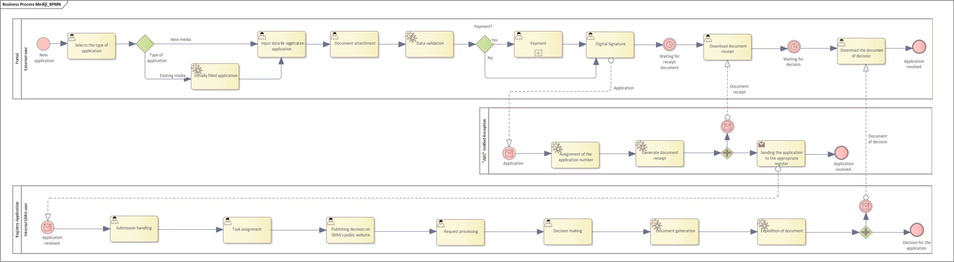
Figure 3 BPMN diagram of the registration process

https://apr.gov.rs/registers/media/about-register.1727.html

